**OLIVER BEACH ELEMENTARY SCHOOL PTA**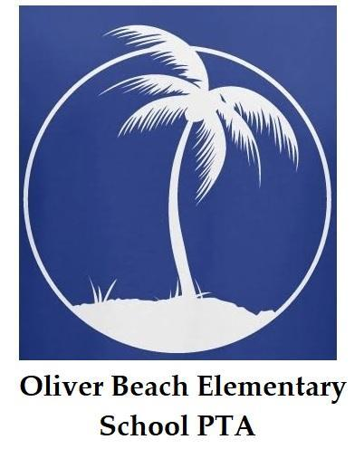

**12912 Cunninghill Cove Rd, Baltimore, MD 21220**

[**oliverbeachpta@gmail.com**](mailto:oliverbeachpta@gmail.com) **|** [**www.oliverbeachpta.org**](http://www.oliverbeachpta.org) **|** [**(410) 887-5943**](https://www.google.com/search?client=safari&rls=en&q=oliver+beach+elementary+school&ie=UTF-8&oe=UTF-8)_________________________________________________________________________________________

**2024-2025 Oliver Beach Elementary School PTA Scholarship**

The Oliver Beach Elementary School PTA is offering a $500 college scholarship to high school seniors who are alumni (former students) of Oliver Beach Elementary School in Middle River.

Guidelines and General Information:

* The scholarship can be used at any college or career school for tuition, books or other college fees.
* This scholarship is available to one qualified student.*
* Application deadline is May 31, 2025.
* The scholarship is reserved for applicants who will attend any college or career school in the fall of 2024 as a full-time student.

To be considered for this $500 Oliver Beach Elementary School PTA Scholarship, the following must be provided:

1. Academic high school transcripts with a cumulative GPA of 2.5 or above.
2. Completed OBES Scholarship Application.
3. One confidential letter of reference from an adult (excluding relatives).
4. A 1-2 page explanation of the following:
   1. Reason for applying for this scholarship
   2. Interests, career plans, and personal objectives
   3. School activities or other organizations involved with
   4. Community service details

All applications will be reviewed by the Scholarship Committee and the winner will be contacted via email by May 31, 2025. If you do not respond and claim the winning scholarship by June 15, 2025, the scholarship will be forfeited and a new applicant will be selected.

**Please MAIL the required documentation and application to the Scholarship Committee at**

**Oliver Beach Elementary School**

**12912 Cunninghill Cove Road**

**Baltimore, MD 21220**

**ATTN: OBES PTA- SCHOLARSHIP COMMITTEE**

If you have any questions, please contact Daria Greensfelder at oliverbeachpta@gmail.com.

*\* If the PTA Scholarship Committee votes result in a tie, an opportunity for 2 winners may exist.*